WEEK 2

QUERIES ON INSURANCE DATABASE

Q1) LIST THE ENTIRE PARTICIPATED RELATION IN THE DESCENDING ORDER OF DAMAGE AMOUNT.

**select \***

**from participate**

**order by damage_amount desc;**

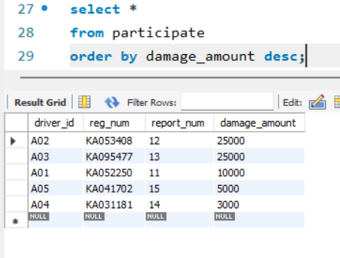

Q2) FIND THE AVERAGE DAMAGE AMOUNT.

**select avg(damage_amount)**

**from participate;**

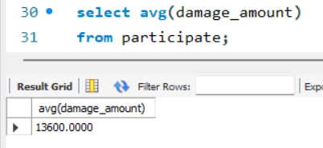

Q3) LIST THE NAME OF DRIVERS WHOSE DAMAGE IS GREATER THAN THE AVERAGE DAMAGE AMOUNT.

**select p.name from person p,participate a**

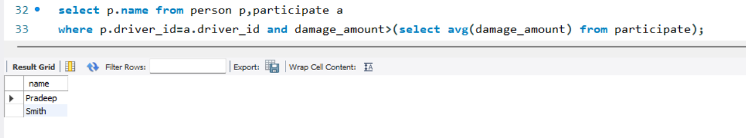**where p.driver_id=a.driver_id and damage_amount>(select avg(damage_amount) from participate);**

Q4) FIND MAXIMUM DAMAGE AMOUNT.

**select max(damage_amount)**

**from participate;**

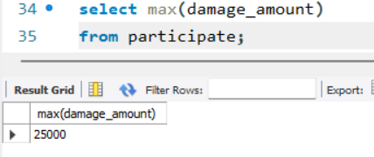

Q5) Display the entire CAR relation in the ascending order of manufacturing year.

**select \***

**from car**

**order by year asc;**

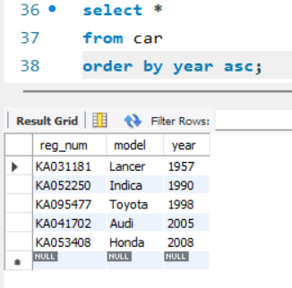

Q6) Find the number of accidents in which cars belonging to a specific model (example 'Lancer')

were involved.

**select count(report_num)**

**from car c,participate p**

**where c.reg_num=p.reg_num and c.model='Lancer';**

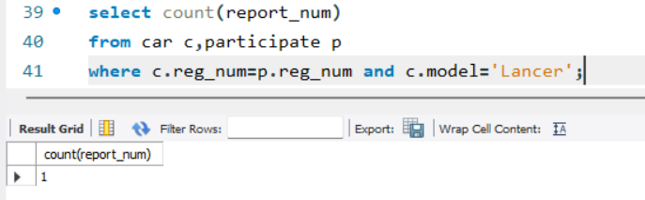

Q7) Find the total number of people who owned cars that were involved in accidents in 2008.

**select count(distinct driver_id)CNT**

**from participate a,accident b**

**where a.report_num=b.report_num and b.accident_date like'__08%';**

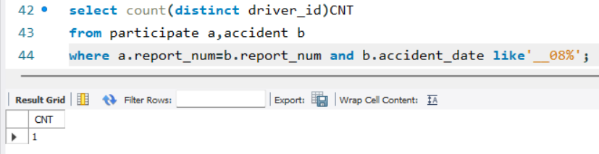

Q8) DELETE THE TUPLE WHOSE DAMAGE AMOUNT IS BELOW THE AVERAGE DAMAGE AMOUNT

**delete from participated**

**where damage_amount<(select t.amt from (select avg(damage_amount) amt from participated) t);**

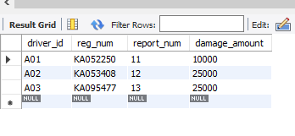

ON SPOT QUERY)

Find driver_name, model of a car and the damage amount that participated in accident at location mysore road.

**insert into participated values('A04','KA031181',14,3000),('A05','KA041702',15,5000);**

**select per.name,c.model,p.damage_amount**

**from person per,car c,participated p,accident a**

**where per.driver_id=p.driver_id and c.reg_num=p.reg_num and a.report_num=p.report_num and a.location='Mysore road';**

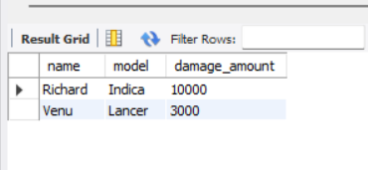

Submitted By,

Shivani Sathyanarayanan

1BM21CS203

D SECTION-D1 BATCH